Decatur Adventist Junior Academy
Grades 5-8 Class
Supply List
2026-2027

- Bible (KJV)
- 2 packs of 36 pre-sharpened Ticonderoga pencils
- 1 pair of children’s scissors
- 1 Zippered Pencil Case
- 3 Composition Notebooks (for math, science, and bible)
- 1 Headphones
- 2 bottles of Purell/hand Sanitizer (for classroom use)
- 2 large containers of Clorox or Lysol Wipes (for classroom use)
- 2 packs of fine tip dry erase markers
- 1 pack of Expo dry erase markers
- 4 boxes of Kleenex (for classroom use)
- 8 small Elmer’s glue sticks
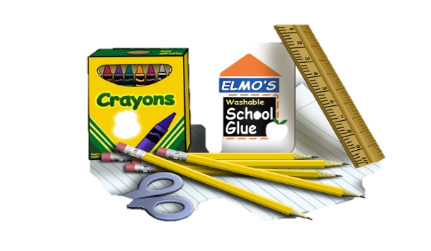
This Photo by Unknown Author is licensed under CC BY-NC-ND

